**AI Enemy**

<https://www.youtube.com/watch?v=zNJEvAGiw7w&list=PL4G2bSPE_8ukuajpXPlAE47Yez7EAyKMu>

1. Create a Third person template.
2. Create AI folder in Content Browser
3. Create a new character (Name it AI Enemy)
4. Open it add skeleton mesh (Mannequin)
5. Add Thirdperson Anim BP
6. Create a new AIController (From blueprint class)
7. Create Behaviour Tree and BlackBoard
8. Select AI controller in enemy character defaults
9. In AI Enemy character BeginPlay - add BP run behaviour tree
10. 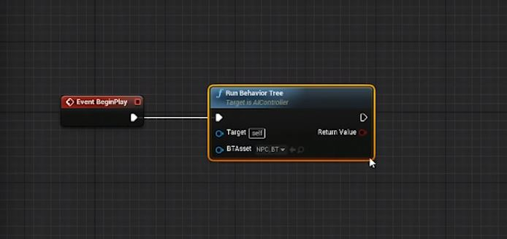
11. Select our behaviour tree in Run Behaviour Tree node.
12. Open Behaviour Tree (it is a decision making tree)
13. Drag from root and pick selector and then choose sequence. Add another sequence
    1. Selector selects and sequence play in sequence
    2. Explain numbers
14. Drag enemy into level.
15. Drag in nav mesh bound volume in to scene(scale and hit p to show)
16. In BlackBoard create a new key of type Vector and name it ActorLocation
17. Back to Behaviour tree.
18. Create new task by clicking on New Task button.
19. Create Execute event and finish execute
20. 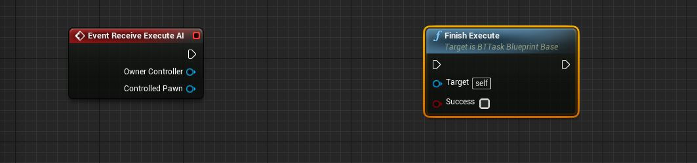
21. Create new variable of type BlackboardKeySelector, Name it Vector.
22. Set Variable to be public
23. Add following Blueprint
24. 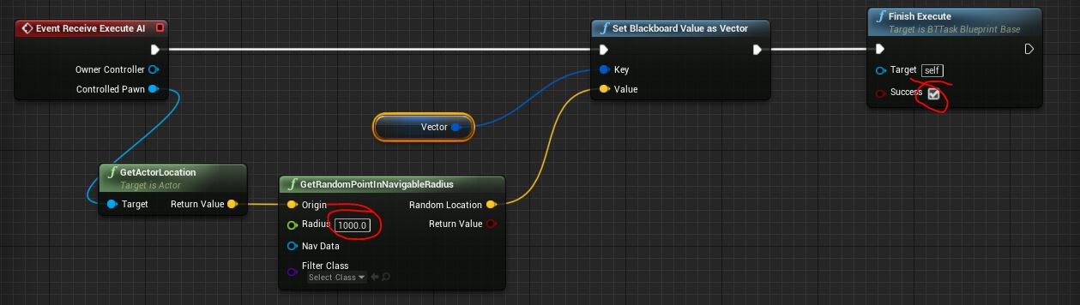
25. Rename the task to a logical name
26. Add the new task to Behaviour tree as follows
27. 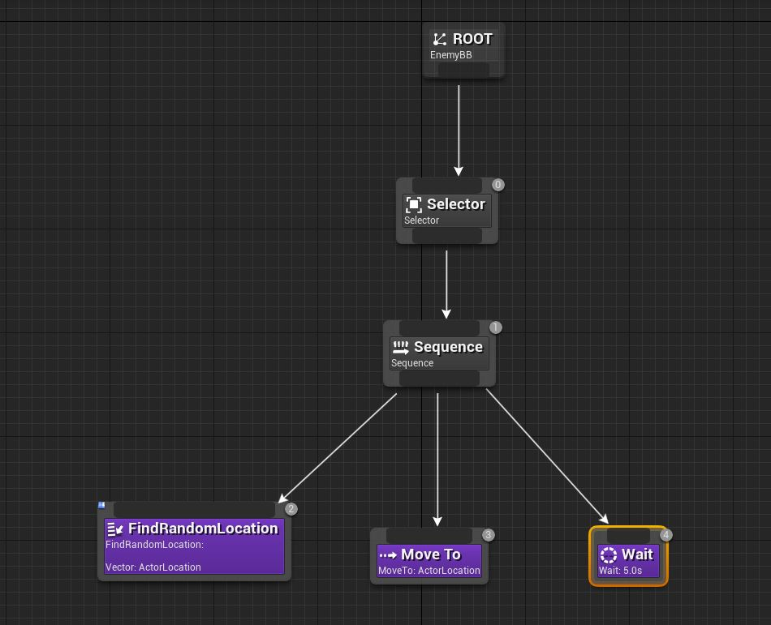
28. Compile and the character should run to Random locations in the level.
29. To avoid snap rotation of the character do the following
    1. In class defaults - Uncheck "Use Controller Rotation Yaw"
    2. In CharacterMovement - Check "Orient Rotation to Movement"
30. We can rename the Sequence to "Go to Random Location"
31. Create another sequence Chase Player.
32. Create new Task.
33. Add Event Receive Execute AI and Finish Execute like in step 19
34. Create a variable of type blackboard key selector
35. Add the following Blueprint
36. 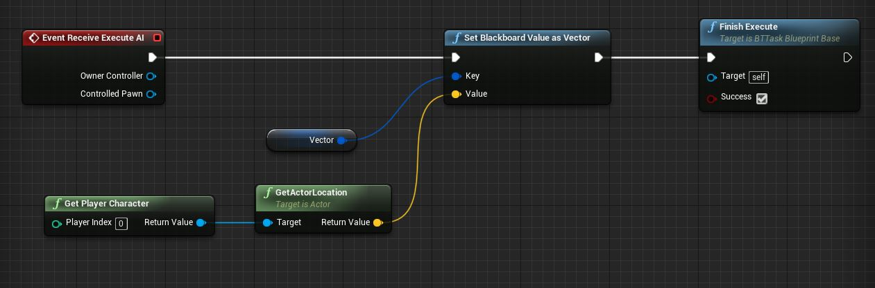
37. Rename the task in content browser
38. Add the task in Behaviour Tree under new sequence as follows
39. 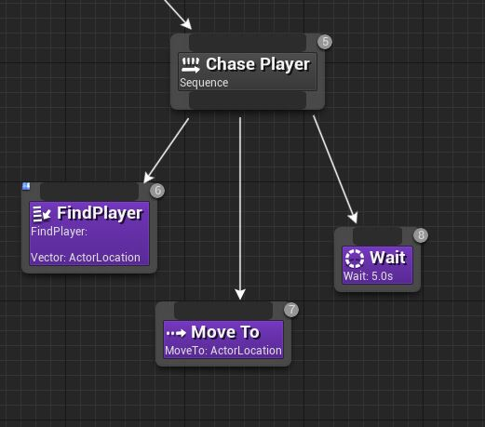
40. To decide if the enemy has found the player we need a boolean (to switch between 2 sequences)
41. For that create a boolean in Blackboard "CanSeePlayer"
42. Now we will give the sequences a decorator. (which decides if we want to go to the sequence)
43. Right click on "Go to Random Loc" sequence and go to Add Decorator and select Blackboard.
    1. A blue decorator will appear on the sequence
44. Select it and in details panel change Key Query to "is not set" and Blackboard Key to "can see player"
    1. Basically it says if blackboard key "can see player" is not set, only then do the sequence.
45. We can rename the decorator.
46. Add another decorator on the other sequence and set the opposite to the cant see decorator.
47. 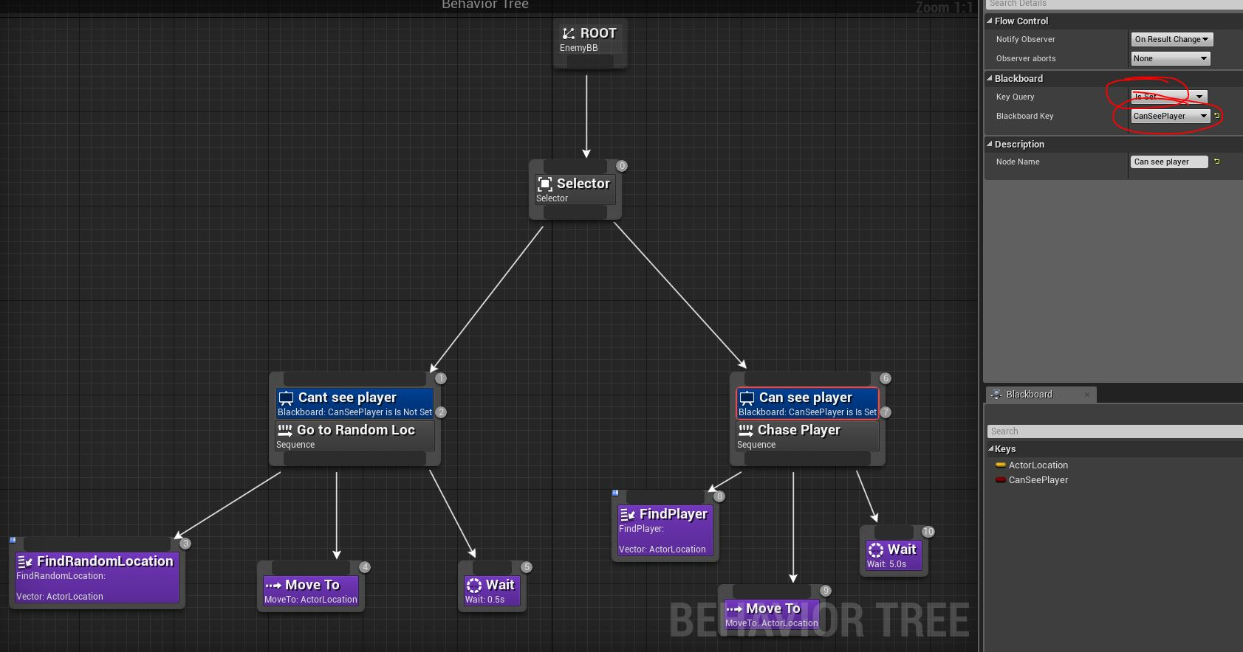
48. Now we need to set the boolean
49. For that go to AIController and add a component AIPerception
50. Select the AIPerception and
51. Add a senses config
52. Change category to AI Sight Config
53. Open it and check all in Detections by affiliation
54. 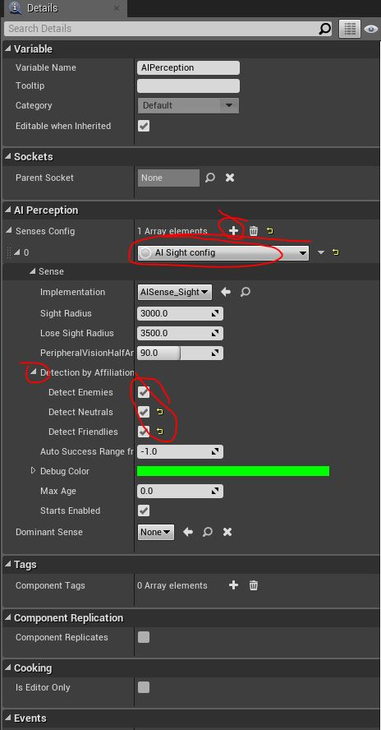
55. Now go to Player Character and add "AIPerceptionStimuliSource" component.
56. Go to its details and check auto register as source
57. Add array element
58. and select AISense_Sight in array element
59. 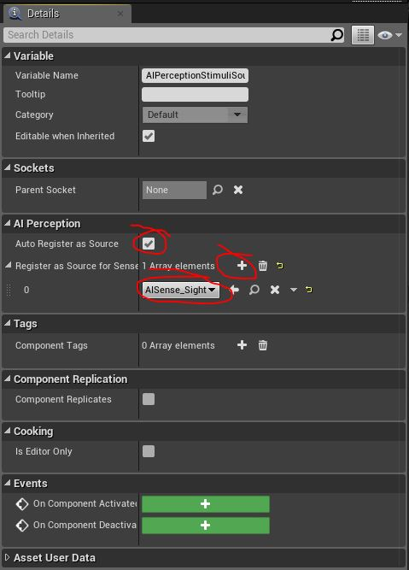
60. Now Go to AIPlayerController and select AIPerception and right click and search "OnTargetPerceptionUpdate" then add the following BPs
61. 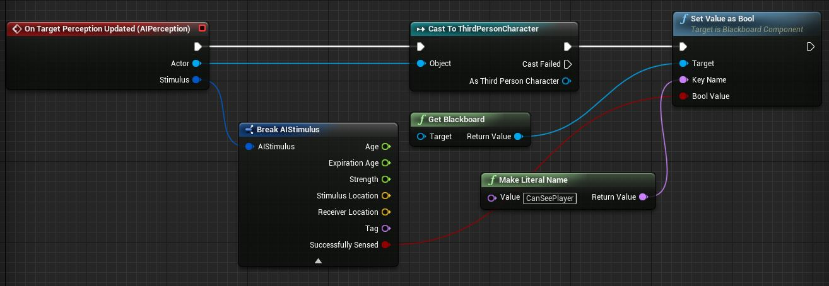
62. Compile and run